GIT

Commands:

1. git config --global user.name “Jayprasanth”
2. git config --global user.email jayprasanth2002@gmail.com
3. Git init
4. git remote add origin <https://github.com/Jayprasanth/First-Commit>
5. git add .
6. git status
7. git commit – m “First commit”
8. git push origin master

Demo of push:

1.

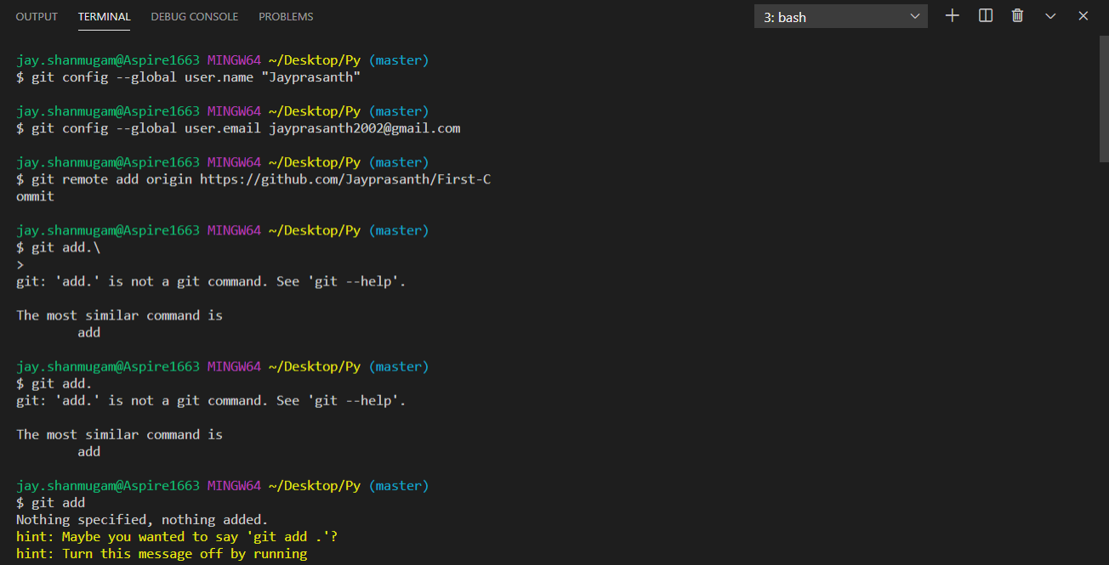

2.

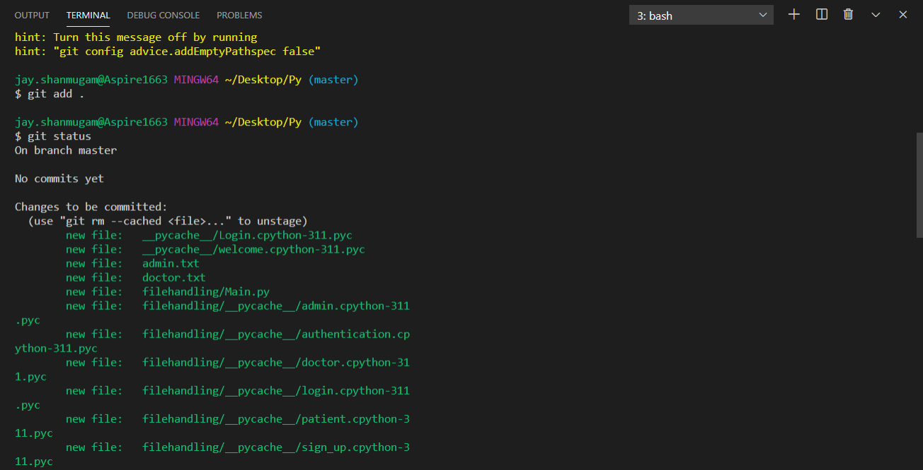

3.

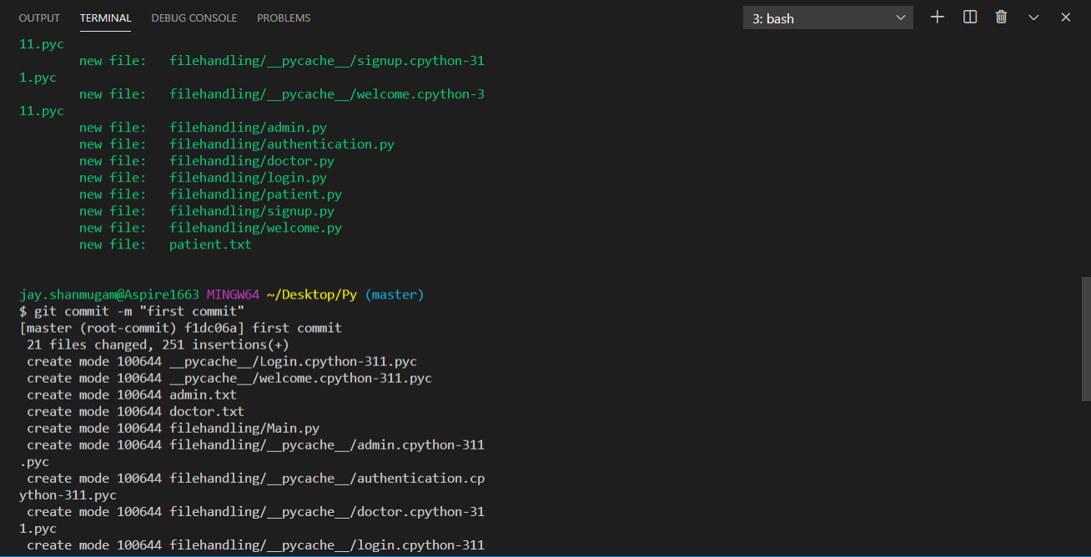

4.

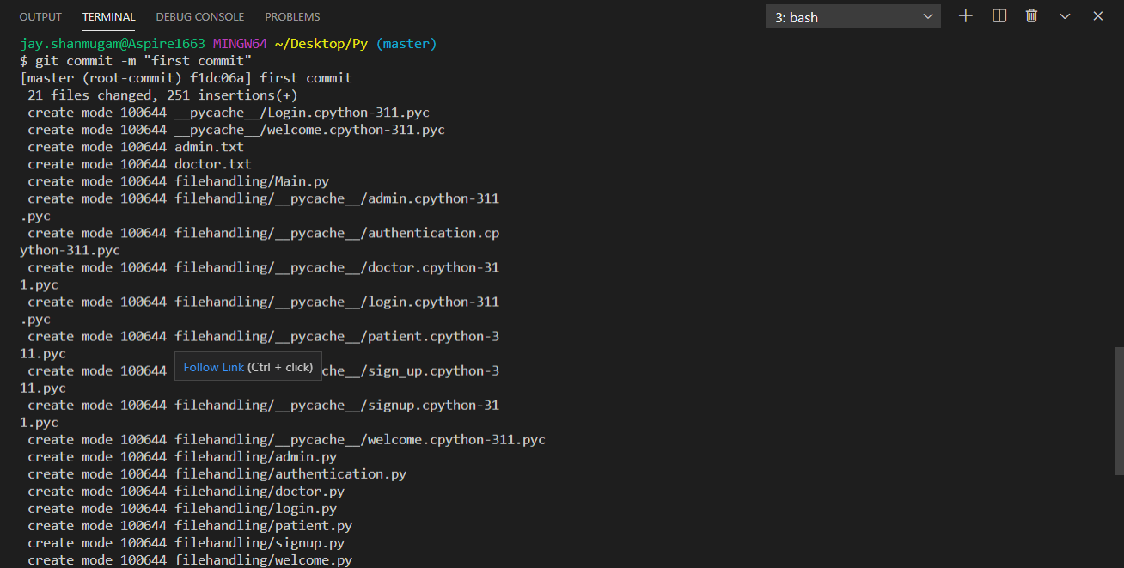

5.

